Claude Results for Fixing the code
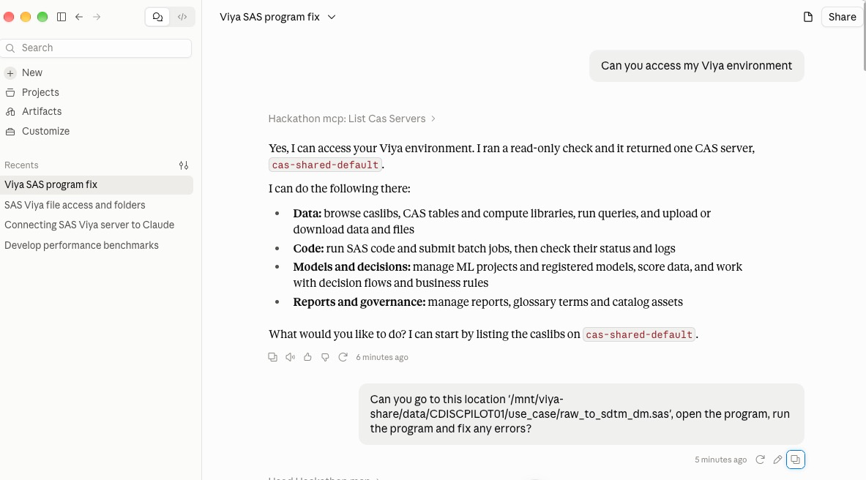
I'll start by loading the tools for reading the file and running SAS code.
The path looks like a server file system path, so I'll read the program through the SAS compute session.
I've read the program (236 lines). I'll run it as written to see what errors come up.
The program fails because its variable names don't match the raw file, and the sdtm library isn't assigned. Next I'll look at the raw data and the folder for any specs.
That was a bug in my directory-listing code, not in your program. I'll fix it and re-run.
The put output isn't showing in this reused session, so I'll retry in a fresh one.
The use_case folder has the DM specifications, so I'll read those to get the mappings right.
The program now runs without errors. It produced sdtm.dm with 15 subjects, one per USUBJID and no duplicates, and the derived USUBJID matched the raw one for every subject. I left your original raw_to_sdtm_dm.sas untouched and saved the corrected version next to it as raw_to_sdtm_dm_fixed.sas. The output is in a new folder, use_case/sdtm_out/, so the existing data under tabulations/sdtm isn't affected.
What was wrong
- Libref: sdtm was never assigned, so the final data step, sort, freq and contents all failed.
- Variable names: the program used names that aren't in raw_dm.csv (CTPATNO, INV, BIRTHDT, CONSENTDT, DEATHDT, ETHNIC_RAW, ARM_RAW, COUNTRY_RAW and others). I mapped it to the real columns: SUBJID, SITEID, BRTHDAT_RAW, ICDAT_RAW, SEX_RAW and RACE_RAW.
- Numeric import: PROC IMPORT read SITEID and SUBJID as numbers, which dropped the leading zeros and caused the type-conflict and $BEST errors. I now read the CSV in a data step so both stay character.
- Dates: they were already SAS dates, so the anydtdte. parsing wasn't needed.
Things for you to confirm
- Race codes: I mapped CA to WHITE, AF to BLACK OR AFRICAN AMERICAN and AS to ASIAN. EA (2 subjects), HP (2) and O (1) are left blank and listed in a mapping exception report, since your own spec says not to map unexpected values silently. Please confirm what those codes mean.
- Age: the raw file has no age, so I derived it as completed years at the informed consent date. Confirm that's the right reference date.
- Blank variables: ETHNIC, ARMCD, ARM, COUNTRY, DTHDTC, DTHFL, RFSTDTC and RFENDTC are empty because raw_dm.csv has no source for them. I didn't invent values. They need other sources, such as randomization data, exposure data or a site-to-country list.

